What is a Use Case Document?

-In software and systems engineering, a **use case** is a list of actions or event steps typically defining the interactions between a role (known in the Unified Modeling Language (UML) as an actor) and a system to achieve a goal. The actor can be a human or other external system.

Why use Use Cases

* 1. Better form of documentation
     1. Smaller more manageable documentation than a single file for the entire program.
  2. Use Cases as Communication
     1. These are written from the user’s point of view so they assist in letting all involved maintain the correct view into what they are doing.

How to Develop a Use Case(From University of Missouri-St Louis)

1. Identify who is going to be using the system directly(actors):
2. Pick one of those actors.
3. Define what that actor wants to do with the system.
4. For each of those Use Cases decide on the most usual course the actor uses the system(what normally happens)
5. Describe the basic course in the description
6. Add the alternatives and add those as extending use cases.

Tips for a good Use Case Document:

1. Make each step show an action. Each step will be unique, but you generally will use one of five steps
   1. The actor provide information
   2. The actor makes a choice
   3. The system provides information
   4. The system asks for information
   5. The system does some work
2. Keep it simple
   1. Don’t use if statements
      1. If statements can become black holes of your time. You will need a then statement and then possibly countless nested If statements.
   2. Be generic in your description.
      1. Instead of saying, “The customer enters the account number into the account number box.” Just write “the customer enters the account number.
   3. Be productive without perfection
      1. “Often so many new product managers think being perfect will impress their audience, but having strongly written use cases with a few mistakes is FAR better than an over complicated detailed list that confuses and bores an audience.”
3. Identify actors and their common use cases
   1. 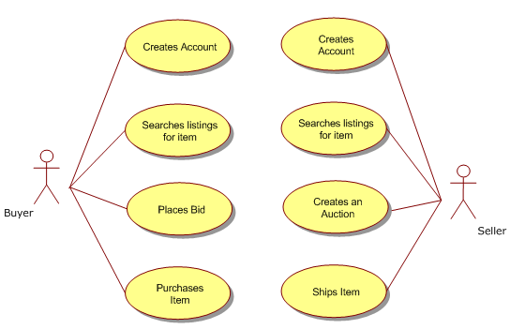
   2. Identify use cases that can be re-used.
      1. In the example above that would be Creates Account, and Searches Listings for Item.
      2. This allows us to create a generic actor to do these “re-usable” cases. Instead of having to create those cases new for each and every actor.

IBM Use Case Document Templates.

<https://www.ibm.com/developerworks/rational/library/content/legacy/parttwo/1000/0670/0670_Schneider_Ch07.pdf>

References:

<https://www.umsl.edu/~sauterv/analysis/488_f01_papers/Prossman/Development.htm>

<http://dthomas-software.co.uk/resources/frequently-asked-questions/why-implement-use-cases/>

<http://www.gatherspace.com/use-case-examples/>

<https://en.wikipedia.org/wiki/Use_case>